SEM Position Efficiency Determination with U⁷³⁺ at 300 MeV/u
Date of experiment: October 18th, 2014
Peter Forck
Abstract: A possible position sensitivity of the SEM detector at HTP was tested by irradiation with U⁷³⁺ at 300 MeV/u of about 10⁷ ions per spill. The beam was scanned vertically from about -20 mm to +30 mm (horizontally centred) and horizontally from -10 mm to +25 mm (vertically at about -8 mm). No significant position sensitivity was found. The ratio between the IC and the SEM counts deviate significantly by 18 % from the value calculated by SRIM and the secondary electron yield determined earlier a GSI.
Goal and method
The SEM installed at HTP was irradiated by various ion beams for long times period e.g. during the experiments for screen investigations during the last years. Surface modification might occur leading to position sensitivity of the secondary electron yield.
On October 18th the positon sensitivity was tested within a beam time of about 20 min with a U⁷³⁺ beam at 300 MeV/u extracted slowly with ≈ 200 ms. The beam intensity per pulse varied from about 6⋅10⁶ ppp to 10⋅10⁶ ppp. The counts of the SEM HTPDI1S were compared to the counts from the IC HTPDI1I. The range of the SEM current-to-frequency converter was set to 100 nA full scale and the IC current-to-frequency converter was set to 10 µA full scale. The SIS dc-transformer was in the range 3mA/V. The gated dc-transformer signal between the events ‘flattop reached’ and ‘start slow extraction’ was used for the determination of the particle within SIS. Typical single spill signals are shown in Fig. 1. Data stored by Ablass-Trend program were used for evaluation. The total counts for the SEM were about 6000 to 9000 per spill and for the IC about 0.7⋅10⁵ to 1.3⋅10⁵ per spill. A self-test of SEM and IC performed on Nov. 4th delivered an accuracy deviation of less than - 0.3 % for the SEM and +2 % for the IC, respectively; this coincide with the results from self-tests recorded several weeks prior to the experiment.
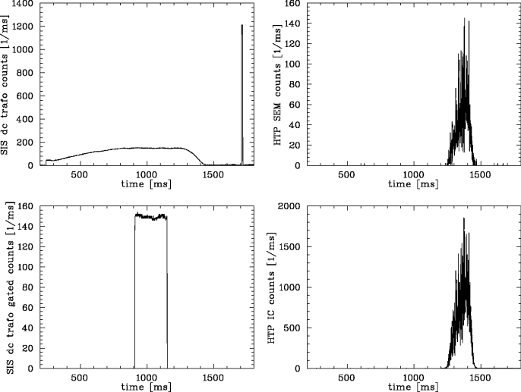
Figure 1: Single spill data from dc-transformer, the gated dc-transformer signal and the SEM and IC.
The position of the beam was monitored by the Chromox screen HTPDF2 and stored by CUPID. A typical online display is shown in Fig. 2. The centre of the beam is determined by the image projection after camera noise subtraction as depicted in Fig. 3. The width of the beam is about σ_{x} ≈ σ_{y} ≈ 2 mm. By the steerer HTTKY1 the vertical position was varied within -22 mm < y_{mean} < 30 mm and with the dipole TH4MU1 the horizontal position was changed within -10 mm < x_{mean} < 23 mm. The profile width was basically constant during both scans.
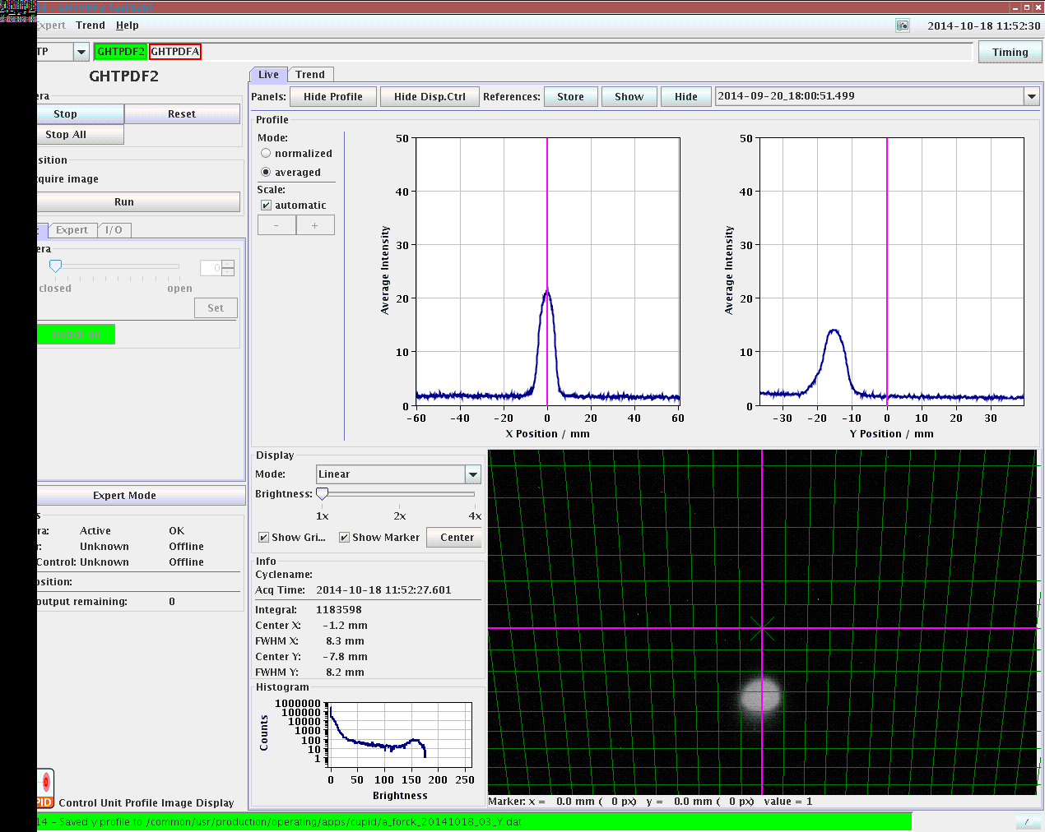
Figure 2: The display from CUPID; the camera pixel are partly in saturation. Nevertheless, the evaluation of the centres x_{mean} and y_{mean} is trustful.
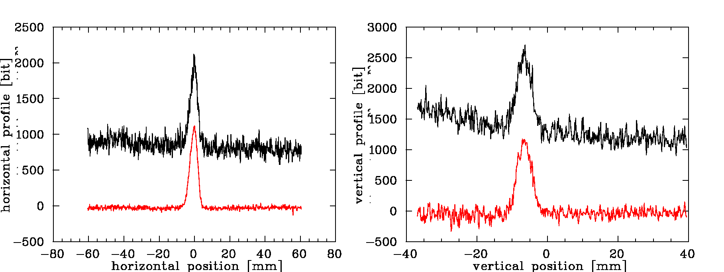
Figure 3: Projections of the screen image (black) and the profile after camera noise subtraction (red) of data without saturation of the CCD pixels.
Experimental results
The ratio of the SEM counts with respect to the counts by the IC and the dc-transformer is shown in Fig. 4 as a function of the beam centre position of the vertical sweep within the large range -21 mm < y_{mean} < +28 mm. The SEM data normalized to the IC data seems to be incorrect for large negative offsets of about y_{mean} ≈ -20 mm, because the IC has only a diameter of 50 mm and, in connection with the assumption of a vertical misalignment (see below), the beam passed the active area incompletely. This is supported by the lower variation of the SEM counts normalized to the dc-transformer for these large vertical offsets. Figure 5 depicts the same raw data but normalized to the average of the central data y_{mean} > -12 mm. It is clearly seen that the variation of the SEM efficiency is below ±5 % if normalized to the IC and below ±2 % if normalized to the dc-transformer. The error bars for the plots were not calculated. Figure 6 shows the horizontal sweep in the range -10 mm < x_{mean} < +23 mm. For this direction the deviations are below ±5 % for the normalization to the IC and ±1 % for the normalization to the dc-transformer.
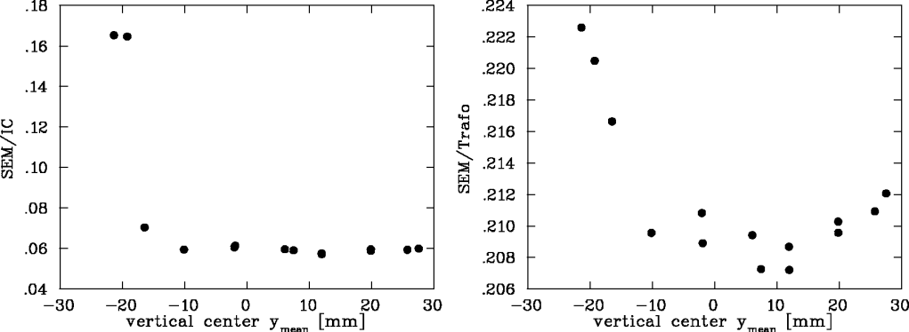
Figure 4: SEM efficiency by a variation of the vertical position. The value of the horizontal deflecting magnet was not changed resulting in a horizontal position of -0.8 mm < x_{mean} < 0.2 mm.
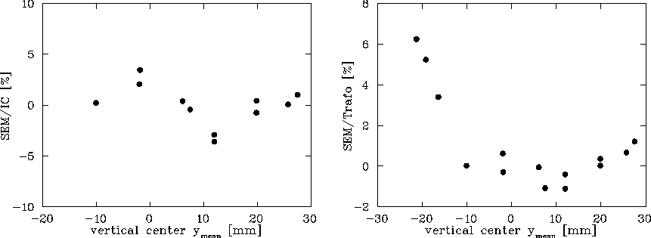
Figure 5: Subset of the data (left) and full data set (right) of Fig. 4 normalized to the mean value for y_{mean} > -12 mm.
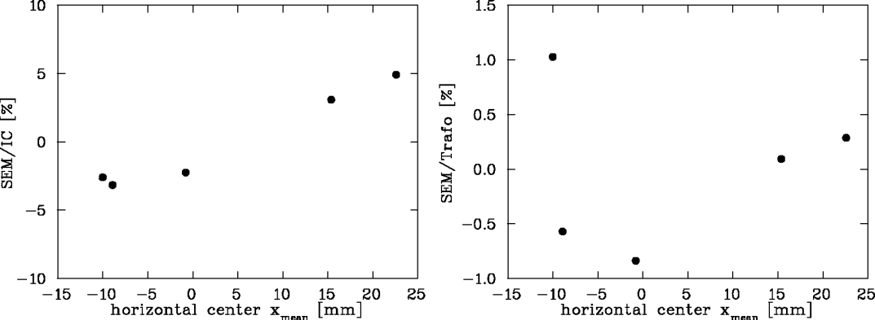
Figure 6: SEM efficiency by a variation of the horizontal position with a normalization to the mean value. The value of the vertical steerer was not changed resulting in a vertical position of -10.1 mm < y_{mean} < -5.3 mm.
Discussion
Position-dependent efficiency: No significant position deviation was found within the estimated uncertainties (the error bars were no calculated in a stringent manner here). For the case of low values for the vertical scan the normalization to the IC differs significantly, but this can be explained by the smaller size of the IC with ∅50 mm active range and the assumption that there is a vertical misalignment of about 10 mm between the central position of the IC and the screen; this assumption supported by the finding using BIF. The variation in the central part of both scan directions is below the expected (but no calculated in a stringent manner) resolution of the SEM, IC and dc-transformer.
Secondary electron yield: The IC measured the charge generation within the 7 mm active volume; using SRIM the beam intensity is calculated. The signal for the SEM is generated by secondary electrons emitted from the surface and in earlier measurements the secondary electron yield was determined. For the given experimental parameters a ratio by this calculation SEM/IC_{theo} = 0.0720 is expected. The measurement by the central part of Fig. 4 leads to the ratio SEM/IC_{exp} = 0.0593. This is a deviation of 18 % with the SEM is less sensitive as expected or, equivalent, the IC is more sensitive as calculated. This large deviation is unexpected. It should be compared to the data recorded during the experiments for the screen investigations.

