Measurement at X2 concerning Schottky on October 28 and 31, 2011
Peter Forck and Piotr Kowina

Abstract:
A first test concerning the longitudinal Schottky Noise observation at a LINAC was done using a pill-box cavity with a resonance frequency of 1.3 GHz and compared to a ring-shaped pick-up. As a result only a narrow band of 40 kHz width was observed in both detectors. This line is probably due to the coherent bunch signal and not due to Schottky Noise.

The ingestions are related to the question why Schottky Noise is not used at LINACs as a diagnostics for the momentum spread as done at many synchrotrons.
A test was done at GSI target location X2 on October 28 and 31, 2011. The beam was only available for about 2 hour each.
Beam parameters: U³⁹⁺ of typical beam current of 300 μA and a pulse length of 150 μs. The ion source is MEVVA and the HSI was used for acceleration. Stripping is done at 1.4 MeV/u using a carbon foil. Further acceleration is done at 108 MHz Alvarez structure. The bunch spacing correspond to 36.136 MHz. Typical transverse beam width was FWHM = 5 mm.
Pill box cavity: The diameter of the cavity is xxx mm, the resonance frequency is tuned to f_{r}=1.30078 GHz with a width of 1.83 MHz corresponding to a quality factor of Q_{L}≈700. A magnetic coupling loop with critical coupling was used. Figure 1 shows the resonance curve of the cavity as determined via S11 meausrement. A pre-amp (Mini-Circuits ZX60-33LN-S+) with 18 dB amplification and 0.05 to 3 GHz bandwidth was connected. The length of the RG214 cable form the target at X2 to Messstation is about ≈ 40 m; it has ≈ 12 dB damping at 1.3 GHz.
Capacitive pick-up: A circular PU of 50 mm inner diameter matched to 50 Ω was used, no pre-amp was connected.
Readout: The signals from both detectors are digitized by the oscilloscope Tektronix DPO 7254 (2.5 GHz, up to 40 GSa/s). The internal FFT calculation was used. The trigger of the oscilloscope is synchronized to the rf with a delay of ≈ 50 µs with respect to the start of the pulse. This trigger signal is taken from the HKR ‘Phas-Oscilloscope’. The spectrum analyzer Textronix RSA 3303A could not be forced to display reliable spectra due to some disturbing line close to 1.3 GHz (this will be improved!).

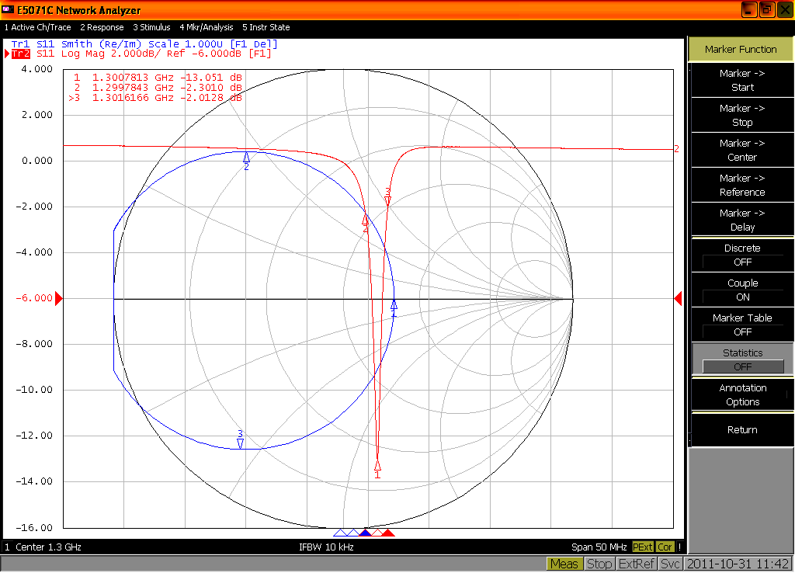
Figure 1: S11 of the cavity as determined by a NWA

The following refer to the beam measurement on Monday October 31.
Figure 2 shows the bunch shape from the PU and the cavity. With both detectors a broad-band signal is seen. Conclusion: The cavity has a much more broad-band characteristic as expected; this might be due to action of the coupling loop as a capacitive pick-up or as a magnetic loop coupling directly to the beam’s electric or magnetic field.

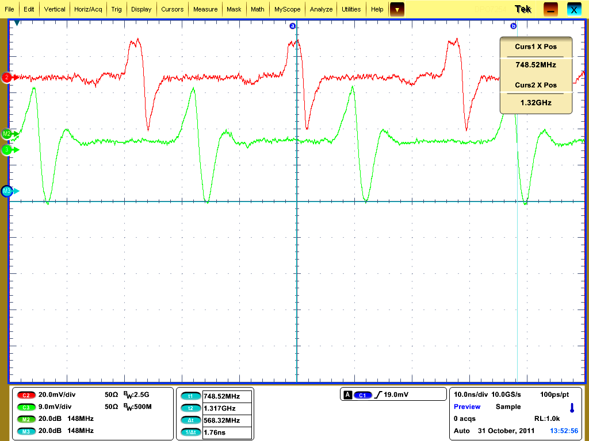
Figure 2: Display of the signal for the PU (CH2, red, 20 mV/div) and cavity (CH3, green, 9 mV/div), 10 ns/div.

The coarse structure of the macro-pulse is shown in Figure 3.
Conclusion: The envelope of both detectors show the same time structure

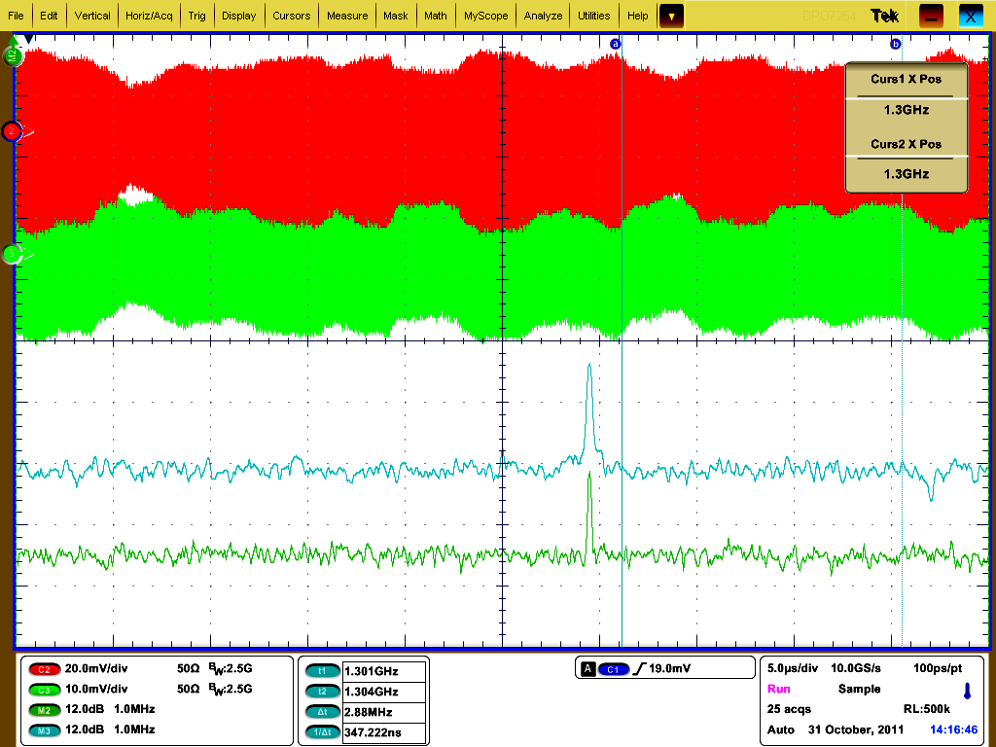

Figure 3: Display of the signal for the PU (CH2, red, 20 mV/div) and cavity (CH3, green, 10 mV/div), 5 µs/div.

Figure 4 shows the full FFT for both detectors.
Conclusion: Both show a broad-band response to the bunches with some differences: The PU has a broader response with significant lines up to 1 GHz. For the cavity no significant stronger line exists at 1.3 GHz.
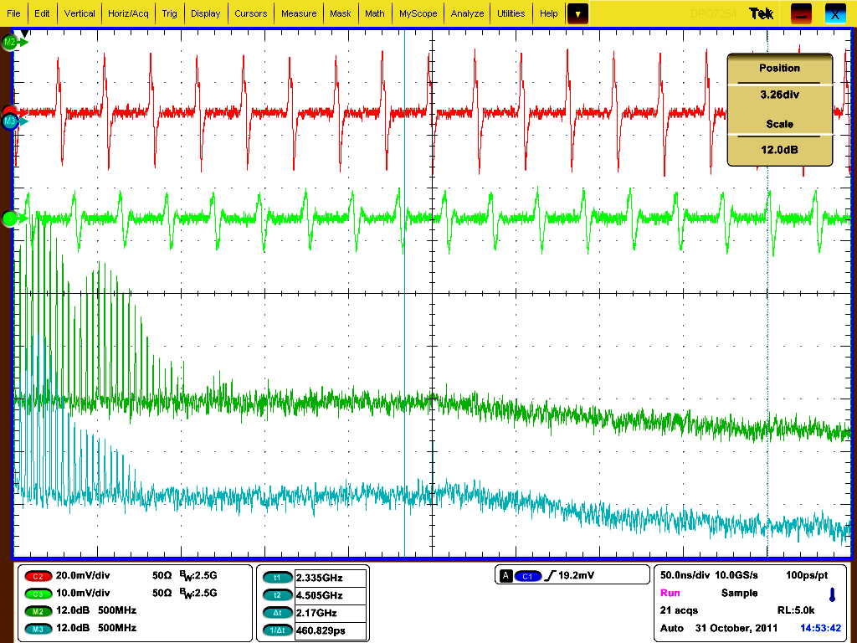
Figure 4: Display of the signal for the PU (CH2, red, 20 mV/div) and cavity (CH3, green, 10 mV/div), 50 ns/div. The FFT is shown for PU (M2, green) and cavity (M3, cyan) with 500 MHz/div, 21 averages are recorded.

Using sufficient averages the frequency component at 1.3 GHz can be extracted and is shown in Figure 5 and 6.
Conclusion: A line exists for both detectors and is located exactly at the same frequency. The signal from the PU is about 15 dB higher, but the signal-to-noise ratio is the same for both signal. The line width for both detectors is about 40 kHz and is mainly given by the resolution bandwidth of 20 kHz.

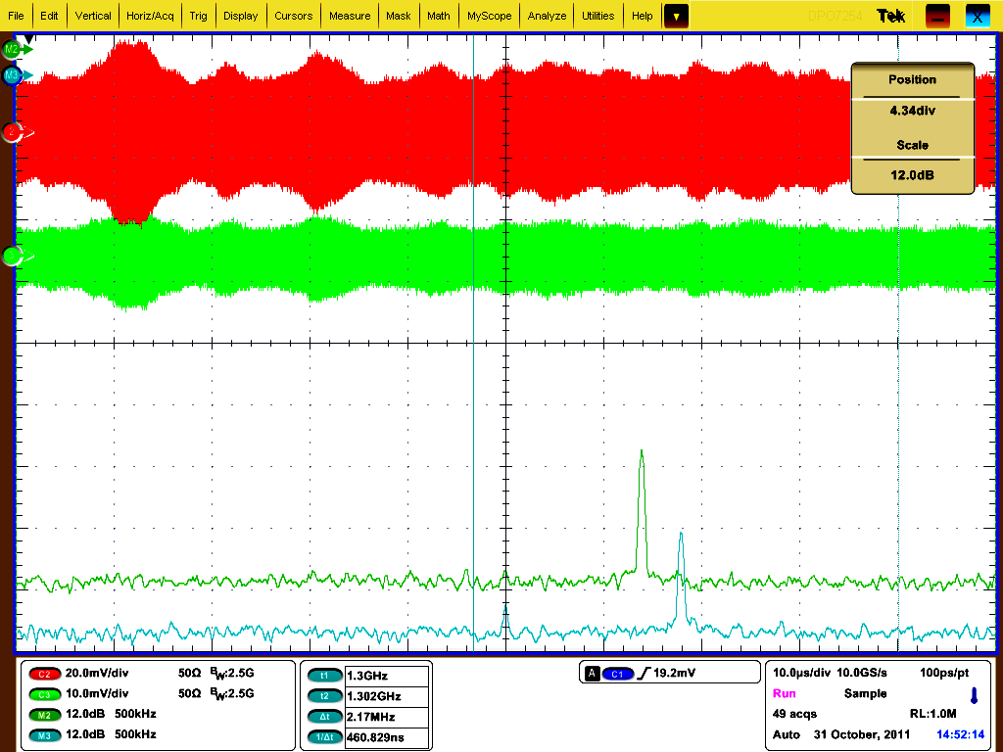
Figure 5: Display of the signal for the PU (CH2, red, 20 mV/div) and cavity (CH3, green, 10 mV/div), 10 µs/div, 10 GSa/s. The FFT is shown for PU (M2, green) and cavity (M3, cyan) with 12 dB/div, 0.5 MHz/div, resolution bandwidth 20 kHz, Hanning-Filter, 49 averages are recorded. The shift between both peaks is artificial, see Figure 6.

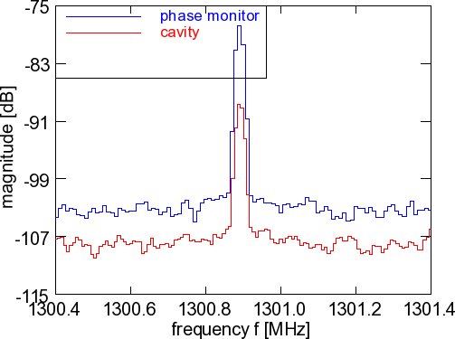
Figure 6: Same frequency spectra as of Figure 5.

General conclusion: An expected broad Schottky band with Δf ≈ 1 MHz was not observed with the used method; this width would correspond to the expected momentum spread of Δp/p ≈ 10⁻³. The spectrum is dominated by the ‘coherent’ bunch component at the 36th harmonics of 36 MHz bunch repetition (with 108 MHz acceleration frequency). Furthermore, no ‘synchrotron sidebands’ were observed.
Presently the following technical topics must be discussed:
- Does the FFT functionality of the oscilloscope give a reliable spectrum?
- Was the observed span of the spectrum (5 MHz) too small for the observation of a Schottky line?
- Why there is no significant frequency filtering by the cavity?
- Why does the spectrum analyzer not show a reliable spectrum in the used mode?
- Why is the ‘coherent’ bunch component such dominant?

