Calibration of IFC current-to-frequency converters
for slow-extraction reference detectors at HTP

- Reiter
Beam Instrumentation LO-BI
13th January 2015

Abstract

Following the extended beam time in 2014, the two current-to-frequency converters for ionisation chamber HTPDI1I and SEM detector HTPDI1S were calibrated with a Keithley current source. These detectors serve as reference detectors for intensity measurements during experiments with slow extraction.

These data serve for two purposes:
- to provide a data set for all experimenters that used the two reference detectors
- to investigate the difference between SEM and ionisation chamber response had been observed by P. Forck (see “Report on possible position dependence of the HTP SEM”, http://www-bd.gsi.de/dokuwiki/doku.php?id=fair-rnd:beamtimes:overview).

The data were taken in November and December 2014 during the shutdown. Two series of calibrations were performed independently by V. Lavrik and A. Reiter with different hardware. Generally, the agreement between the two data sets is good, apart from the case of the most sensitive 100 nA range for the ionisation chamber HTPDI1I. The effect remains unexplained.

Table Of Contents
1 Hardware Setup 3
1.1 Calibration 1 (November 2014) 3
1.2 Calibration 2 (December 2014) 5
1.2.1 Setup & Measurement Procedure 5
1.2.2 Data Format 6
1.2.3 Data Analysis 7
2 Results 8
2.1 Ionisation Chamber HTPDI1I 8
2.1.1 Range 1 – 10 µA full scale 8
2.1.2 Range 2 – 1 µA full scale 9
2.1.3 Range 3 – 100 nA full scale 9
2.2 SEM Detector HTPDI1S 10
2.2.1 Range 2 – 1 µA full scale 10
2.2.2 Range 3 – 100 nA full scale 11
2.3 “Re-analysis” of HTPDI1I and HTPDI1S discrepancy 11
3 Selected Calibration Data 13
3.1 Calibration Data HTPDI1I 13
3.2 Calibration Data HTPDI1S 16

Hardware Setup

Calibration 1 (November 2014)

Experimenter: V. Lavrik

Used hardware:
- Current source: Keithley 261 current source
- IFC3 output monitor: Ablax (Ablass Expert)

Calibration runs:
- One series for each gain range and detector. The data are reported in Table 1.
- On the Ablax server the data can be found in folder:
/spill/user_data/vlavrik/20141111/
Table 1: Calibration data for detectors HTPDI1S and HTPDI1I
HTPDI1S |  |  | HTPDI1I
Range1 |  |  | Range1
Current, A | Counts |  | Current, A | Counts
1,0000E-06 | 99 |  | 1,0000E-06 | 102
2,0000E-06 | 201 |  | 2,0000E-06 | 204
3,0000E-06 | 306 |  | 3,0000E-06 | 308
4,0000E-06 | 414 |  | 4,0000E-06 | 413
5,0000E-06 | 525 |  | 5,0000E-06 | 520
6,0000E-06 | 638 |  | 6,0000E-06 | 626
7,0000E-06 | 755 |  | 7,0000E-06 | 734
8,0000E-06 | 873 |  | 8,0000E-06 | 844
9,0000E-06 | 999 |  | 9,0000E-06 | 959
1,0000E-05 | 1117 |  | 1,0000E-05 | 1071
Range2 |  |  | Range2
Current, A | Counts |  | Current, A | Counts
2,0000E-08 | 19 |  | 2,0000E-08 | 20
5,0000E-08 | 49 |  | 5,0000E-08 | 51
7,0000E-08 | 68 |  | 7,0000E-08 | 72
9,0000E-08 | 88 |  | 9,0000E-08 | 92
1,0000E-07 | 98 |  | 1,0000E-07 | 101
5,0000E-07 | 507 |  | 5,0000E-07 | 497
8,0000E-07 | 830 |  | 8,0000E-07 | 794
1,0000E-06 | 1056 |  | 1,0000E-06 | 988
Range3 |  |  | Range3
Current, A | Counts |  | Current, A | Counts
1,0000E-09 | 8 |  | 1,0000E-09 | 10
1,0000E-08 | 90 |  | 1,0000E-08 | 101
3,0000E-08 | 270 |  | 3,0000E-08 | 265
5,0000E-08 | 477 |  | 5,0000E-08 | 440
7,0000E-08 | 679 |  | 7,0000E-08 | 613
9,0000E-08 | 863 |  | 9,0000E-08 | 736
1,0000E-07 | 1004 |  | 1,0000E-07 | 801

Calibration 2 (December 2014)

Setup & Measurement Procedure
Experimenter: A. Reiter

Used hardware:
- Current source: Keithley 2600 source meter & 1 MOhm resistor at output which
is important to avoid excessive noise
- IFC3 output monitor: Ablass measurement with two “shutdown machines” VAcc 1
and Vacc 2. A 10 MHz reference clock for normalisation of integration windows and conversion of raw data to IFC output rate, i.e. measured current, was used. Data were exported from Ablass into ASCII files.

Calibration runs:
- HTPDI1I: Range 1 Calibration: - [0.20 µA; 10.0 µA] 200 nA/step
- Range 1 - [15.0 µA; 9.5 µA] 500 nA/step
- Range 1 - [19.5 µA; 9.5 µA] 500 nA/step
- Range 2 - [1.50 µA; 0.05 µA] 50 nA/step
- Range 3 - [0.15 µA ; 0.005 µA] 5 nA/step
- HTPDI1S Range 3 + [0.15 µA; 0.005 µA] 5 nA/step
- Range 3 + [0.00 µA; 0.024 µA] 1 nA/step
- Range 2 + [0.00 µA; 0.975 µA] 25 nA/step

The Keithley source was remotely controlled and the output current changed in regular intervals during a single scan. The control software was not synchronised to the VAcc execution; hence, some measurements were excluded during which the output current was changed.
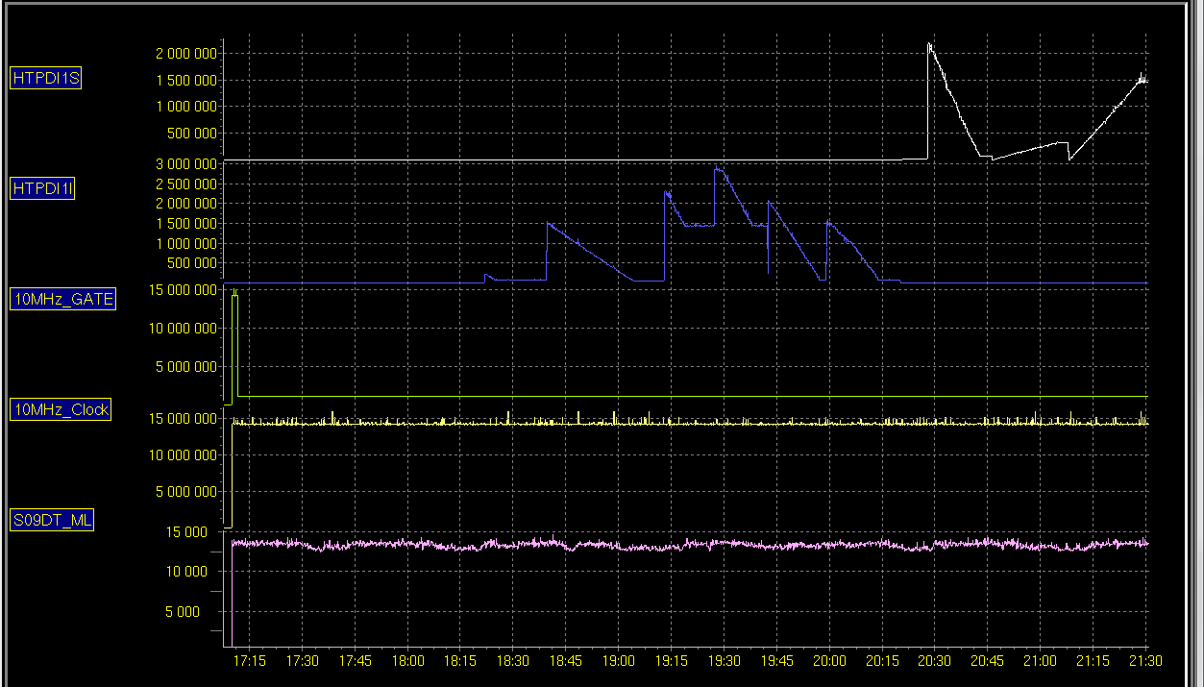
Run 1
Run 5
Run 4
Run 3
Run 2
Run 6
Run 7
Run 8

Figure 1: Measurement sequence shown as trend data in Ablass for HTPDI1S (white trace) and HTPDI1I (blue trace). The 10 MHz reference clock is shown in yellow colour.

Data Format

A fraction of the exported ASCII data is shown in Table 2 for illustration. In total 22017 cycles and data for 5 detectors were exported which contain the seven calibration series. These had to be identified manually in the data file.

Table 2: Sample sections of the ASCII file showing the header section followed by the count integrals („Zählerendstand“) for each detector, VAcc information and the time stamp. The second data block shows data of HTPDI1I.
5
22017
S09DT_ML
10MHz_Clock
10MHz_GATE
HTPDI1I
HTPDI1S
Devices-VrtAcc-TimeInfo
0.0 0.0 0.0 0.0 0.0 2 18.12.2014 17:09:39:900
0.0 0.0 0.0 1.0 0.0 2 18.12.2014 17:09:44:330
0.0 0.0 0.0 0.0 0.0 1 18.12.2014 17:09:47:080
0.0 0.0 0.0 0.0 0.0 2 18.12.2014 17:09:48:680
0.0 0.0 0.0 0.0 0.0 2 18.12.2014 17:09:53:100
0.0 0.0 0.0 0.0 0.0 1 18.12.2014 17:09:55:830
0.0 0.0 0.0 1.0 0.0 2 18.12.2014 17:09:57:430
3890.0 21149761.0 21138150.0 0.0 0.0 2 18.12.2014 17:10:01:860
13906.0 14223539.0 14223528.0 0.0 0.0 1 18.12.2014 17:10:04:600
30900.0 42076407.0 42076380.0 0.0 0.0 2 18.12.2014 17:10:06:190
11924.0 25474244.0 25474227.0 0.0 0.0 2 18.12.2014 17:10:10:610
13462.0 14253562.0 14253557.0 0.0 0.0 1 18.12.2014 17:10:13:360
26982.0 42070744.0 42070707.0 1.0 0.0 2 18.12.2014 17:10:14:960
12600.0 25344124.0 25344105.0 0.0 0.0 2 18.12.2014 17:10:19:390
13190.0 14323637.0 14323624.0 0.0 0.0 1 18.12.2014 17:10:22:120
: : : : : : :
: : : : : : :
: : : : : : :
11456.0 25614377.0 1220793.0 130131.0 0.0 2 18.12.2014 18:26:39:234
13290.0 14363672.0 1080785.0 72971.0 0.0 1 18.12.2014 18:26:41:994
11436.0 25614383.0 1220790.0 130130.0 0.0 2 18.12.2014 18:26:43:614
13274.0 14223537.0 1080786.0 72261.0 0.0 1 18.12.2014 18:26:46:394
25142.0 42070350.0 2301574.0 213737.0 0.0 2 18.12.2014 18:26:47:994
11444.0 25404173.0 1220789.0 129068.0 0.0 2 18.12.2014 18:26:52:414
13184.0 14183499.0 1080790.0 72060.0 0.0 1 18.12.2014 18:26:55:164
11432.0 25614379.0 1220789.0 130138.0 0.0 2 18.12.2014 18:26:56:764
13244.0 14223542.0 1080784.0 72266.0 0.0 1 18.12.2014 18:26:59:544
25118.0 42026755.0 2301574.0 213531.0 2.0 2 18.12.2014 18:27:01:144
11438.0 25374142.0 1220790.0 128920.0 0.0 2 18.12.2014 18:27:05:564
13434.0 14213529.0 1080785.0 72215.0 0.0 1 18.12.2014 18:27:08:314
24796.0 42037773.0 2301574.0 213586.0 0.0 2 18.12.2014 18:27:09:914
11424.0 25384157.0 1220789.0 128975.0 0.0 2 18.12.2014 18:27:14:334

Data Analysis

The raw data was converted to IFC output rate using the reference clock according to the formula:

I_{Out} = (R_{Det.}/R_{Max.FS}) * I_{Nom.} = ((C_{Det.}/∆t)/R_{Max.FS})*I_{Nom.} = ((C_{Det.}/(C_{Ref.}/R_{Ref.})) / R_{Max.FS} ) * I_{Nom.}

where:
- I_{Out} is the output current (µA)
- I_{Nom.} is the full scale range of a given range (µA)
- ∆t is the scaler acquisition time
- C_{Det.} is the integral number of detector counts registered in the scaler during ∆t
- C_{Ref.} is the integral number of reference clock counts registered in the scaler during ∆t
- R_{Det.} is the average IFC output rate
- R_{Ref.} is the rate of the reference clock (10 MHz)
- R_{Max.FS} is the maximum nominal IFC output frequency at full scale (1 MHz)

Example for IFC range 1 (I_{Nom.}=10 µA):

I_{Out} [A] = (C_{Det.}/C_{Ref.}) * (10 MHz/1 MHz) * 10⁻⁵ [A] = (C_{Det.}/C_{Ref.})* 10⁻⁴ [A]

The calculated currents were then compared to the set source output current. Average values of the acquired number of measurements were calculated for each source current setting.

In this short report statistical uncertainties or proper fits of calibration curves to the data are not included. In some cases a simple trend line has been added. No attempt is made to quantify the agreement or disagreement between the two sets of calibration data. It is merely concerned about the integrity of the data since the automated acquisition procedure has been carried out for the first time.

Results

The following plots present average values of the measured IFC output currents (mean value of all measurement cycles) as function of the source output current.

Ionisation Chamber HTPDI1I

Range 1 – 10 µA full scale

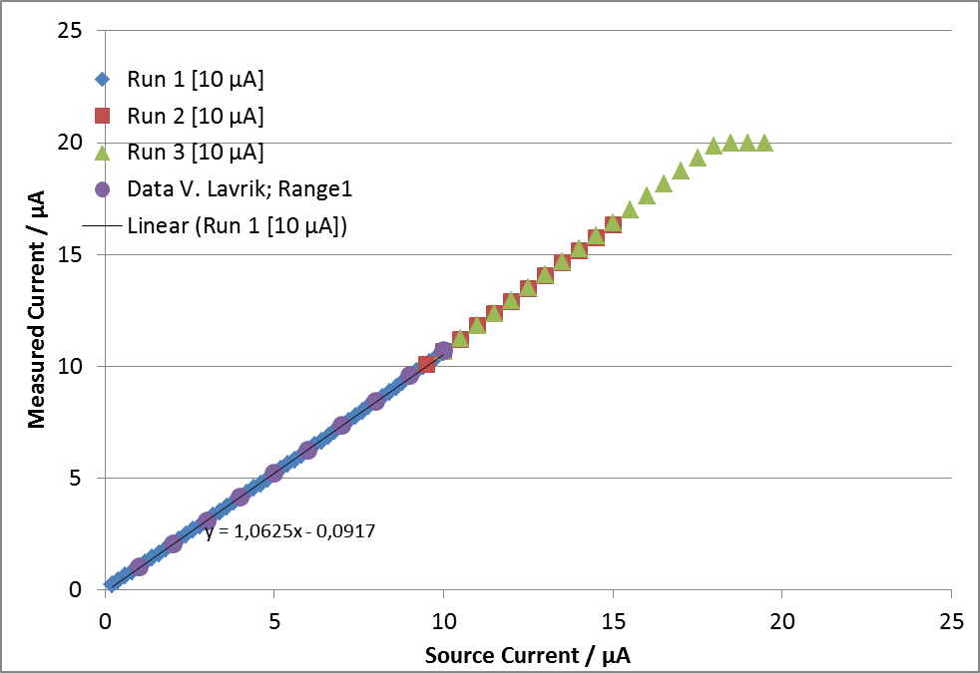

- The IFC output is rather linear over the full scale range of 10 µA (which corresponds to an IFC output rate of 1 MHz), even up to the maximum hardware limit of 20 µA. The maximum output frequenc of the IFC converter is 2 MHz.
- The maximum ionisation chamber signal was about 15 µA, i.e. 50% above the nominal working range, when the discrepancy between HTPDI1I and HTPDI1S was observed. The data of Calibration 2 verify the integrity of those data.
- The data of Calibration 1 (purple) and Calibration 2 (blue, red, green) seem to be in good agreement.
- The IFC overestimates the input current by about 6% (slope=1.063, offset ~ 0.1 µA).

Range 2 – 1 µA full scale

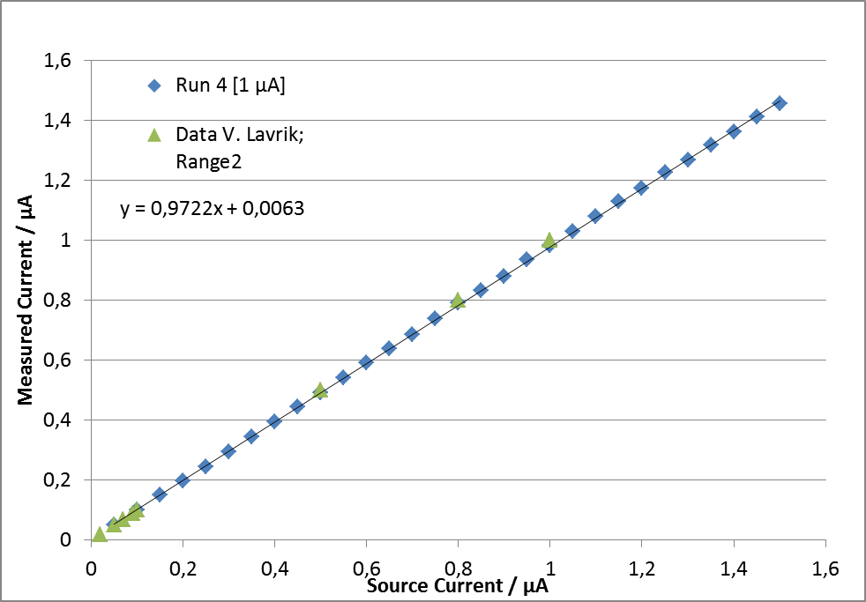

- The data of Calibration 1 (green) and Calibration 2 (blue) seem to be in good agreement.

Range 3 – 100 nA full scale

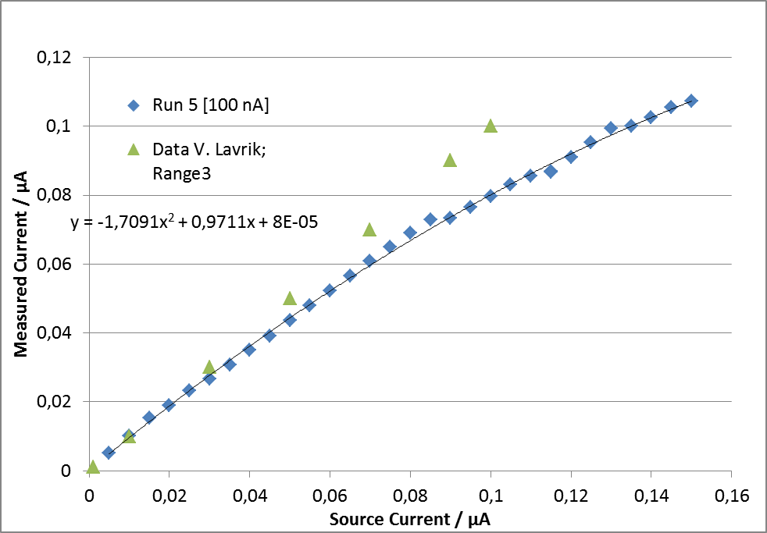

- The data of Calibration 1 and Calibration 2 are in evident disagreement. The reason is not understood. The calibration data for HTPDI1S in range 3, i.e. in the same current range, are in good agreement.

SEM Detector HTPDI1S

Only two measurements in the two most sensitive ranges were performed during Calibration 2. During standard operation Range 1 is not used.

Range 2 – 1 µA full scale

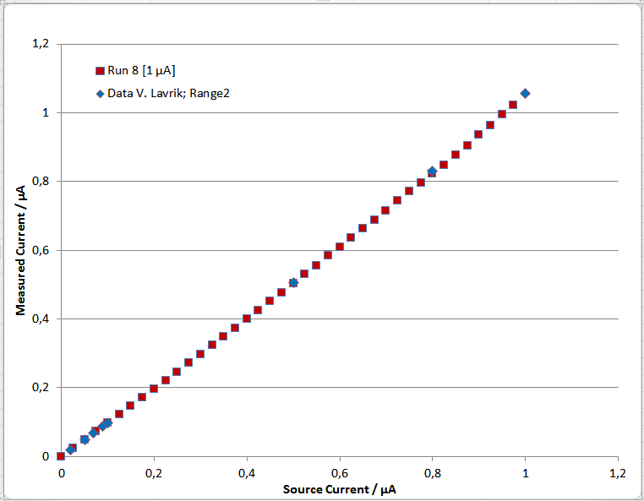

- The data of Calibration 1 (green) and Calibration 2 (blue) seem to be in good agreement.

Range 3 – 100 nA full scale

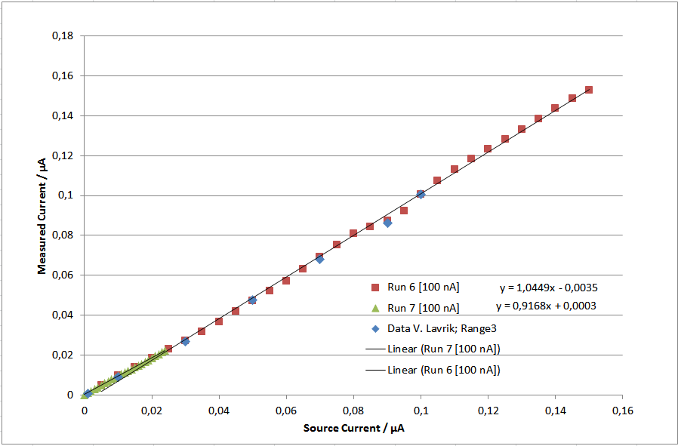

- The data of Calibration 1 (green) and Calibration 2 (blue) seem to be in good agreement. The slight “wiggle” around 90 nA is reproduced in both data sets.
- A callibration in small steps of 1 nA has been acquired in the range up to 25 nA (25% full scale) because the discrepancy between SEM and ionisation chamber was observed in this region.

“Re-analysis” of HTPDI1I and HTPDI1S discrepancy

On the basis of the presented data one may try to review the difference between SEM and ionisation chamber responses that have been observed by P. Forck (see “Report on possible position dependence of the HTP SEM”, http://www-bd.gsi.de/dokuwiki/doku.php?id=fair-rnd:beamtimes:overview). Detector signals are shown in Figure 2 and were taken from that report.
The report states that for the given beam type and energy the expected ration (SEM/IC)_{theor.} = 0.072, while the measured ratio was (SEM/IC)_{exp.}= 0.0593. This discrepancy of 18% is unusually large. Acceptable values would be below 10%.

The calibration data indicate that the SEM detector underestimates the current by ~8%, while the ionisation chamber overestimates the current by ~6%. This leads to a correction factor of 1.14 which has to be multiplied to the experimental ratio:
(SEM/IC)_{exp. corr.} = (SEM/IC)_{exp} * 1.14 = 0.068

The corrected value (SEM/IC)_{exp. corr.} deviates by 6% from the prediction which is acceptable.

Figure 2: The plots show Figure 1 of the report by P. Forck and give an indication of the signal strength of both detectors SEM (top right) and IC (bottom right).

Selected Calibration Data

The following data values represent averages of measured IFC output currents for each source output setting. The raw data is available from the Wiki

Calibration Data HTPDI1I

Run 1 [10 µA]
I source [µA] | HTPDI1I [µA]
10 | 10,61918035
9,8 | 10,39812198
9,6 | 10,18154291
9,4 | 9,97068049
9,2 | 9,748710601
9 | 9,527796121
8,8 | 9,271540093
8,6 | 9,053544831
8,4 | 8,841441152
8,2 | 8,621403792
8 | 8,403938543
7,8 | 8,189407094
7,6 | 7,972509384
7,4 | 7,742944789
7,2 | 7,537530351
7 | 7,310577364
6,8 | 7,095451065
6,6 | 6,873597612
6,4 | 6,666218811
6,2 | 6,452297807
6 | 6,237131002
5,8 | 6,026126
5,6 | 5,81192578
5,4 | 5,602625649
5,2 | 5,385176255
5 | 5,185114029
4,8 | 4,968079505
4,6 | 4,746238502
4,4 | 4,545394148
4,2 | 4,330080868
4 | 4,122221639
3,8 | 3,912960249
3,6 | 3,703650763
3,4 | 3,493533643
3,2 | 3,282946522
3 | 3,076549599
2,8 | 2,868882585
2,6 | 2,661255166
2,4 | 2,453933565
2,2 | 2,247367798
2 | 2,040509906
1,8 | 1,835939852
1,6 | 1,630614752
1,4 | 1,425721501
1,2 | 1,221523073
1 | 1,017571851
0,8 | 0,813765235
0,6 | 0,610300706
0,4 | 0,407092134
0,2 | 0,203907247

Run 2 [10 µA]
I source [µA] | HTPDI1I [µA]
15 | 16,30958073
14,5 | 15,75796501
14 | 15,17899729
13,5 | 14,6120403
13 | 14,04926938
12,5 | 13,47016202
12 | 12,9054736
11,5 | 12,33836275
11 | 11,80219284
10,5 | 11,21739531
10 | 10,66705363
9,5 | 10,09655355

The following table contains the value of 0.115 µA (115 nA) twice. This is not a mistake!
Run 3 [10 µA]
I source [µA] | HTPDI1I [µA]
19,5 | 19,99971969
19 | 19,98675389
18,5 | 19,96965226
18 | 19,86187265
17,5 | 19,30901814
17 | 18,74860808
16,5 | 18,16922895
16 | 17,59588057
15,5 | 17,01276347
15 | 16,41029475
14,5 | 15,83434729
14 | 15,25350855
13,5 | 14,66646554
13 | 14,08603957
12,5 | 13,51412744
12 | 12,92661287
11,5 | 12,34876562
11 | 11,82041689
10,5 | 11,23604613
10 | 10,66990041
9,5 | 10,12357319

Run 4 [1 µA]
I source [µA] | HTPDI1I [µA]
1,5 | 1,454975864
1,45 | 1,411692061
1,4 | 1,360857891
1,35 | 1,317449207
1,3 | 1,268600272
1,25 | 1,225509019
1,2 | 1,173588656
1,15 | 1,128154811
1,1 | 1,078410039
1,05 | 1,029599211
1 | 0,983790279
0,95 | 0,934551219
0,9 | 0,881063804
0,85 | 0,833282492
0,8 | 0,790792714
0,75 | 0,738971207
0,7 | 0,686447752
0,65 | 0,639782205
0,6 | 0,590854586
0,55 | 0,542982206
0,5 | 0,493376251
0,45 | 0,443642574
0,4 | 0,394244573
0,35 | 0,34513071
0,3 | 0,295733639
0,25 | 0,246364365
0,2 | 0,198762396
0,15 | 0,150999817
0,1 | 0,102053012
0,05 | 0,051183495

Run 5 [100 nA]
I source [µA] | HTPDI1I [µA]
0,15 | 0,107351523
0,145 | 0,105422966
0,14 | 0,102520641
0,135 | 0,099998618
0,13 | 0,099435358
0,125 | 0,095370408
0,12 | 0,090954581
0,115 | 0,086903991
0,115 | 0,086757126
0,11 | 0,085547779
0,105 | 0,083187279
0,1 | 0,079711356
0,095 | 0,076486634
0,09 | 0,073272636
0,085 | 0,072915095
0,08 | 0,069006444
0,075 | 0,064905114
0,07 | 0,060792186
0,065 | 0,056488196
0,06 | 0,052293611
0,055 | 0,047976485
0,05 | 0,043623163
0,045 | 0,039234715
0,04 | 0,034967784
0,035 | 0,030745873
0,03 | 0,026567626
0,025 | 0,023189368
0,02 | 0,019068283
0,015 | 0,015257238
0,01 | 0,010198061
0,005 | 0,005085364

Calibration Data HTPDI1S

Run 6 [100 nA]
I source [µA] | HTPDI1S [µA]
0,15 | 0,152814434
0,145 | 0,14864484
0,14 | 0,143654198
0,135 | 0,138410123
0,13 | 0,133169956
0,125 | 0,128145436
0,12 | 0,123170661
0,115 | 0,11816315
0,11 | 0,113112321
0,105 | 0,107298109
0,1 | 0,100482914
0,095 | 0,092233951
0,09 | 0,087333435
0,085 | 0,084494305
0,08 | 0,080795223
0,075 | 0,07538172
0,07 | 0,069171713
0,065 | 0,063090465
0,06 | 0,05727089
0,055 | 0,052208747
0,05 | 0,047222355
0,045 | 0,041887706
0,04 | 0,036720494
0,035 | 0,031691572
0,03 | 0,027268427
0,025 | 0,023248346
0,02 | 0,01852021
0,015 | 0,013813737
0,01 | 0,009794632
0,005 | 0,004870394

Run 7 [100 nA]
I source [µA] | HTPDI1S [µA]
0 | 0
0,001 | 0,000962789
0,002 | 0,001935785
0,003 | 0,00290938
0,004 | 0,003886565
0,005 | 0,004869616
0,006 | 0,00585635
0,007 | 0,006849653
0,008 | 0,007842827
0,009 | 0,008829873
0,01 | 0,009797669
0,011 | 0,010684937
0,012 | 0,01146434
0,013 | 0,012261515
0,014 | 0,012968884
0,015 | 0,01381399
0,016 | 0,014720865
0,017 | 0,01566389
0,018 | 0,016595034
0,019 | 0,017576277
0,02 | 0,018522376
0,021 | 0,019471548
0,022 | 0,020442621
0,023 | 0,021404806
0,024 | 0,022327771

Run 8 [1 µA]
I source [µA] | HTPDI1S [µA]
0 | 0
0,025 | 0,024441609
0,05 | 0,048948431
0,075 | 0,073564085
0,1 | 0,097652715
0,125 | 0,121754564
0,15 | 0,146439093
0,175 | 0,171232149
0,2 | 0,196142655
0,225 | 0,221173789
0,25 | 0,246398731
0,275 | 0,271470555
0,3 | 0,297039108
0,325 | 0,322709496
0,35 | 0,347998413
0,375 | 0,373363754
0,4 | 0,399522607
0,425 | 0,425660005
0,45 | 0,451663957
0,475 | 0,476290612
0,5 | 0,504396493
0,525 | 0,531054482
0,55 | 0,556127171
0,575 | 0,583629582
0,6 | 0,609047919
0,625 | 0,635324028
0,65 | 0,664245683
0,675 | 0,687657835
0,7 | 0,715609677
0,725 | 0,743765811
0,75 | 0,770416434
0,775 | 0,795211402
0,8 | 0,823127976
0,825 | 0,848720449
0,85 | 0,878197849
0,875 | 0,904875949
0,9 | 0,93700591
0,925 | 0,963193612
0,95 | 0,994663661
0,975 | 1,021415769

